Contents

SharePoint 2013: Create a custom Geolocation field that renders using Nokia Maps 2

Description of the sample 3

Prerequisites 3

Key components of the sample 4

Configure the sample 4

Run and test the sample 4

Troubleshooting 4

Change log 4

Related content 5

# SharePoint 2013: Create a custom Geolocation field that renders using Nokia Maps

This documentation is preliminary and is subject to change.

Summary:  You can render data from Nokia maps in SharePoint 2013 Preview by creating a custom field type that inherits from the Geolocation field type.

SharePoint 2013 Preview introduces a new field type named Geolocation that enables you to annotate SharePoint lists with location information. In columns of type Geolocation, you can enter location information as a pair of latitude and longitude coordinates in decimal degrees or retrieve the coordinates of the user's current location from the browser if it implements the W3C Geolocation API. For more information about Geolocation field, see **Integrating location and map functionality in SharePoint 2013**. Geolocation field type is not available in the default content type of any list or document library in SharePoint 2013 Preview. To make this field type available, you need to develop and deploy custom field type controls to your SharePoint sites. The Geolocation field is not user-creatable by default in SharePoint 2013 Preview; you must programmatically add the Geolocation field type to SharePoint. For more information about how to add a Geolocation column programmatically, see **How to: Add a Geolocation column to a list in SharePoint 2013 programmatically**. You can render four SharePoint list views (View, DisplayForm, EditForm, and NewForm) from Nokia maps, as shown in Figure 1.

Figure 1. Custom views of new custom field

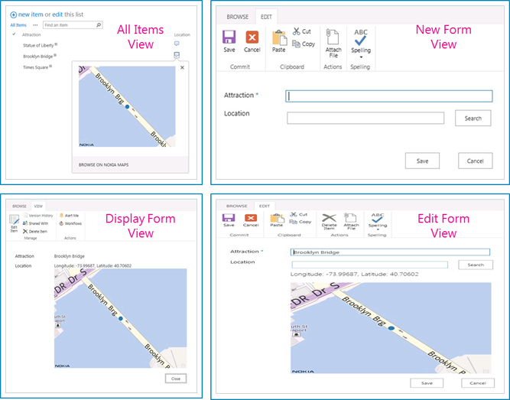

## Description of the sample

After the Geolocation field type is added to SharePoint 2013 Preview, it renders maps by using Bing Maps. By default, the Geolocation field can render only with Bing Maps. You can create a custom field based on Geolocation that provides its own rendering from Nokia Maps. Custom rendering is provided through the JSLink property in the client-side rendering framework, which is introduced in Microsoft SharePoint 2013 Preview. For more information about client-side rendering, see **How to: Customize a field type using client-side rendering**. This code sample demonstrates how to create a custom field by using Geolocation as parent, and also demonstrates how field values can be shown on Nokia Maps.

## Prerequisites

This sample requires the following:

* Microsoft Visual Studio 2012
* SharePoint development tools in Visual Studio 2012
* A SharePoint 2013 Preview development environment

## Key components of the sample

The sample contains the following:

* NokiaMapsCustomField project
* NokiaMapsControl.js   The JavaScript file that provides the logic to render from Nokia Maps. This file needs to be in the LAYOUT folder, which is a mapped SharePoint folder.
* fldtypes_NokiaMapsControl.xml   The XML file that stores the definition of the new custom field type. This file needs to be in the XML folder, which is a SharePoint mapped folder.

## Configure the sample

Follow these steps to configure the sample.

1. Set the SiteUrl property of the project to the URL of your SharePoint server.
2. Rebuild your solution to map all SharePoint mapped folders to your SharePoint server.

## Run and test the sample

Follow these steps to run and test the sample.

1. Choose the F5 key to build the solution.
2. Deploy your solution.
3. Navigate to your SharePoint site, create a column in a SharePoint custom list, and choose the newly created custom field as the field type.
4. Now add a new item in the list. You should be able to search for a location in the newly created extended Geolocation field.

## Troubleshooting

The following table lists common configuration and environment errors that prevent the sample from running or deploying properly and how to solve them.

| Problem | Solution |
| --- | --- |
| Search box does not appear for field created from the extended Geolocation Nokia field type. | Clear browser cache. |
| Error message: Geolocation API is not supported. | The Geolocation feature is supported only for browsers in which W3C Geolocation API is enabled. |

## Change log

| Version | Date |
| --- | --- |
| First version | July 16, 2012 |

## Related content

* **How to: Create a custom Geolocation field that renders using Nokia Maps**
* [Walkthrough: Creating a Custom Field Type](http://msdn.microsoft.com/en-us/library/bb861799.aspx)